**Some end-of-life devices will receive security updates from QNAP**

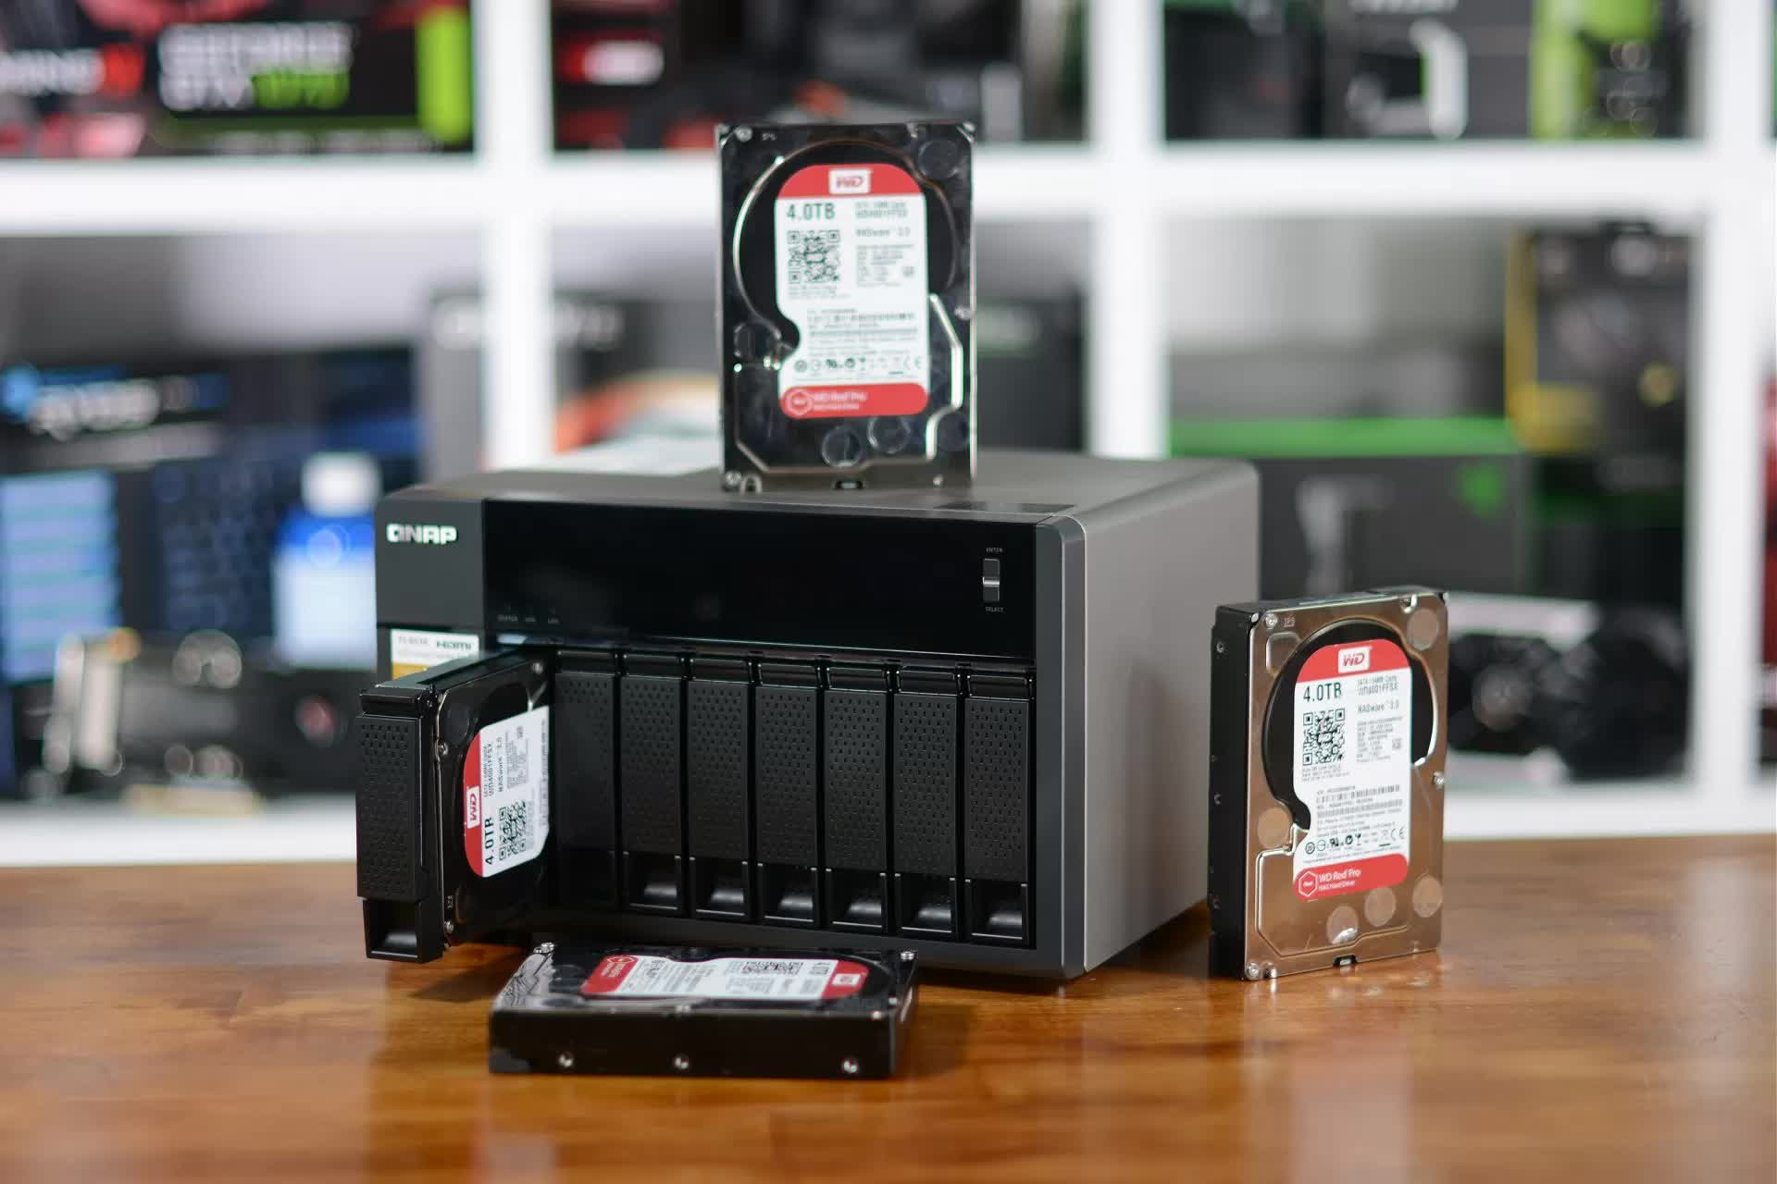

What's at stake: QNAP is extending security upgrades for some older devices past the date when they would normally halt a few weeks following a security issue. Rather than a permanent policy shift, the scenario appears to be an extenuating circumstance.

Quality Network Appliance Provider (QNAP), a Taipei-based IT company, stated this week that it will change the way it manages security for its aged devices for the rest of 2022. While the firm doesn't say so, this is most likely a response to the ransomware attacks that hit its products earlier this month.

It stated that it typically continues to issue security updates for devices four years after their end-of-life (EOL) dates. However, as a result of this announcement, some products that are more than four years old will continue to receive security fixes until October.

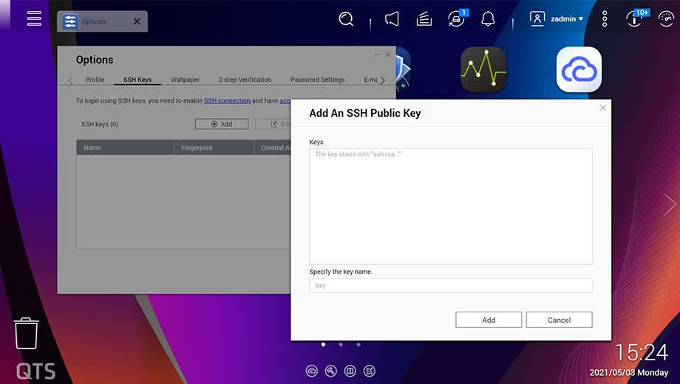

Any Arm or x86 64-bit products that received QTS OS version 4.2.6, 4.3.3, 4.3.6, or 4.4.1 are on the list of affected devices. They will only receive critical or high-priority security upgrades, such as the one QNAP forced on many NAS users at the end of last month to prevent ransomware.

The corporation upgraded its "preferred" OS version in January, resulting in automatic software updates that, although successful in preventing the ransomware, damaged other capabilities for some users. The blunder was caused in part by QNAP's multi-layered auto-update system, which some users were unfamiliar with.